Antenna Placement

Image 1:

GPS antenna
ANT-GNCP-C25L125100

ANT-GNCP-C25L125100

ANT-GNCP-C25L125100

ANT-GNCP-C25L125100

Metal Plate
WIFI & BLE antenna
(3D model of these antenna is different than antenna which we are using, take this 3D model just for reference)

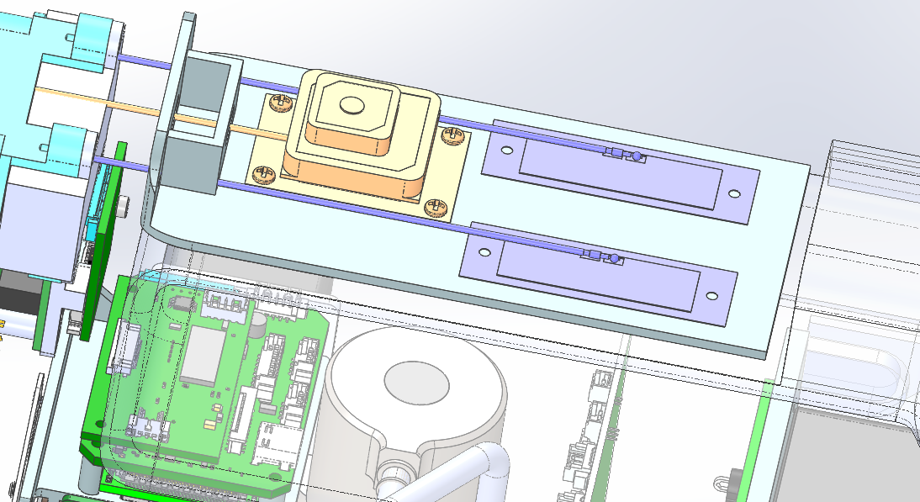

Image 2:

This one is Camera handle at this area we planning this antenna placement. Above image shows cross section of camera handle (Image1)
Plastic upper portion

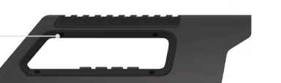
Metal plate is mounted inside here

